Directions: Try to do an activity together each day. Feel free to modify the tasks as needed (use pictures, offer choices, pointing…). For each picture, have your child describe the picture (What is it? What does it look like? Where do you find it? What is it made of?). Use this as a guide throughout the month to reinforce language skills. Have fun communicating!!
May
Speech & Language
Monday | Tuesday | Wednesday | Thursday | Friday | Bonus
Talk about the important dates in May (holidays, birthdays, etc.) | Visit the library and find books about fruit. Talk about your favorite fruits. | Go for a walk and count cars in people’s driveways. | Make a map of your house and label each room. | Make a card for someone special. | Watch a cartoon and talk about what happened.
Sort the laundry and talk about light and dark colors. | Make cookies and talk about the colors of the different ingredients. | Talk about the things in the kitchen that are shaped like a square. | Read a story and have your child turn the pages. | Take a walk and talk about the plants you see. | Go to the store and buy vegetables. Talk about your favorite vegetables.
Form playdough or clay into shapes (e.g., balls, cones, boxes). | Talk about things that make people sad. | Go for a “listening walk” and talk about the different sounds you hear. | Find several boxes and sort them by size. | Find bugs outside and talk about what they look like. | Have another child over for a picnic lunch.  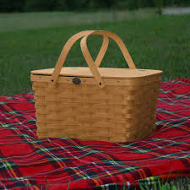
Talk about what you did yesterday. | Taste sugar and salt. Talk about foods that are sweet and foods that are salty. | Look through a jewelry box and describe the various items (e.g., shiny, dull, old, bright)  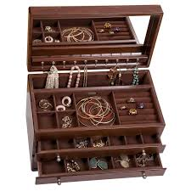 | Fill a jar with beans and use it as a shaker. Play music while shaking it. | Make chocolate milk using milk and chocolate syrup. Talk about each step. | Talk about the weather and draw a picture of a rainy day.
Learning Target: With daily practice in the home, this resource can be used to enhance functional communication and generalization of skills.

