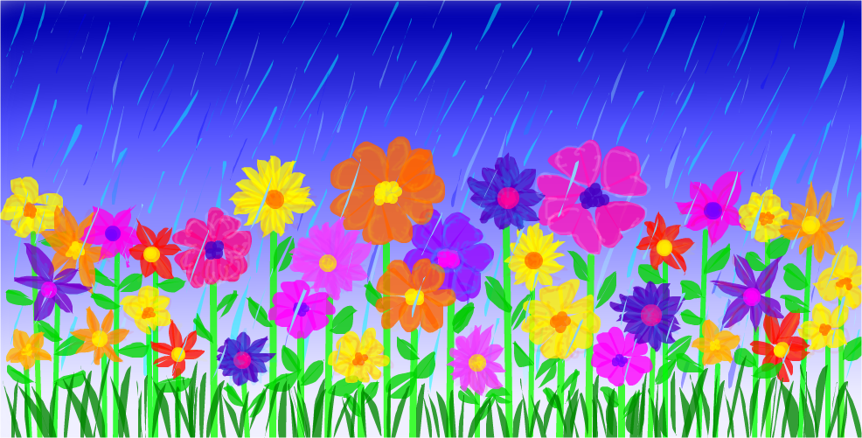
Directions: Try to do an activity together each day. Feel free to modify the tasks as needed (use pictures, offer choices, pointing…). For each picture, have your child describe the picture (What is it? What does it look like? Where do you find it? What is it made of?). Use this as a guide throughout the month to reinforce language skills. Have fun communicating!!
April 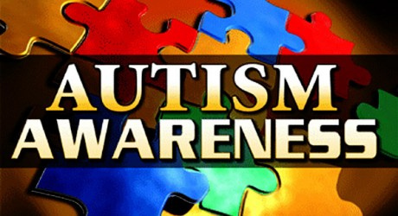
Speech & Language
Monday | Tuesday | Wednesday | Thursday | Friday | Bonus
Talk about the important dates in April (holidays, birthdays, etc.) | Make a fancy sandwich by cutting it into different shapes.  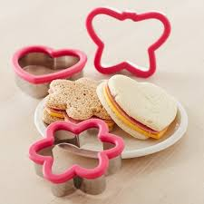 | Talk about different animals people have as pets. | Look outside and find things that are brown. | Find rectangles in the kitchen. | Talk about things that help people stay dry (e.g., raincoat, galoshes, umbrella).
Take turns scooping sand with your hands and filling up a bucket. | Clean the bathtub using a variety of scrubbing motions (e.g., circular, zigzag). | Make ice cubes using fruit juice instead of water. | Sort the books in the house into two piles: big books and little books. | Talk about words that rhyme with cat.  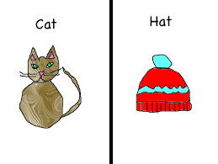 | Draw a picture of your house.
Talk about different types of furniture in a bedroom  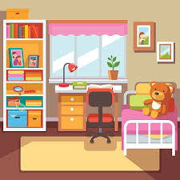 | Write with colored pens and name the different colors. | Read a book about animals and look for the smallest ones. | Talk about things you can ride in (e.g., cars, wagons, airplanes, buses, trains). | Collect sticks outside and arrange them by length. | Go to a store and buy fruit. Talk about their shape, color, taste, where and how they grow.
Name the appliances in the house (e.g., washer, dryer, stove, vacuum cleaner, refrigerator). | Look under furniture and talk about what you find. | Watch the clouds move across the sky. Talk about the shapes they look like. | Look outside and talk about the birds you see.  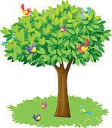 | Talk about signs of danger (e.g., smoke coming from a house, sirens blaring). | Make a tent using a sheet and furniture. Pretend to go camping.
Learning Target: With daily practice in the home, this resource can be used to enhance functional communication and generalization of skills.

