Directions: Try to do an activity together each day. Feel free to modify the tasks as needed (use pictures, offer choices, pointing…). For each picture, have your child describe the picture (What is it? What does it look like? Where do you find it? What is it made of?). Use this as a guide throughout the month to reinforce language skills. Have fun communicating!!
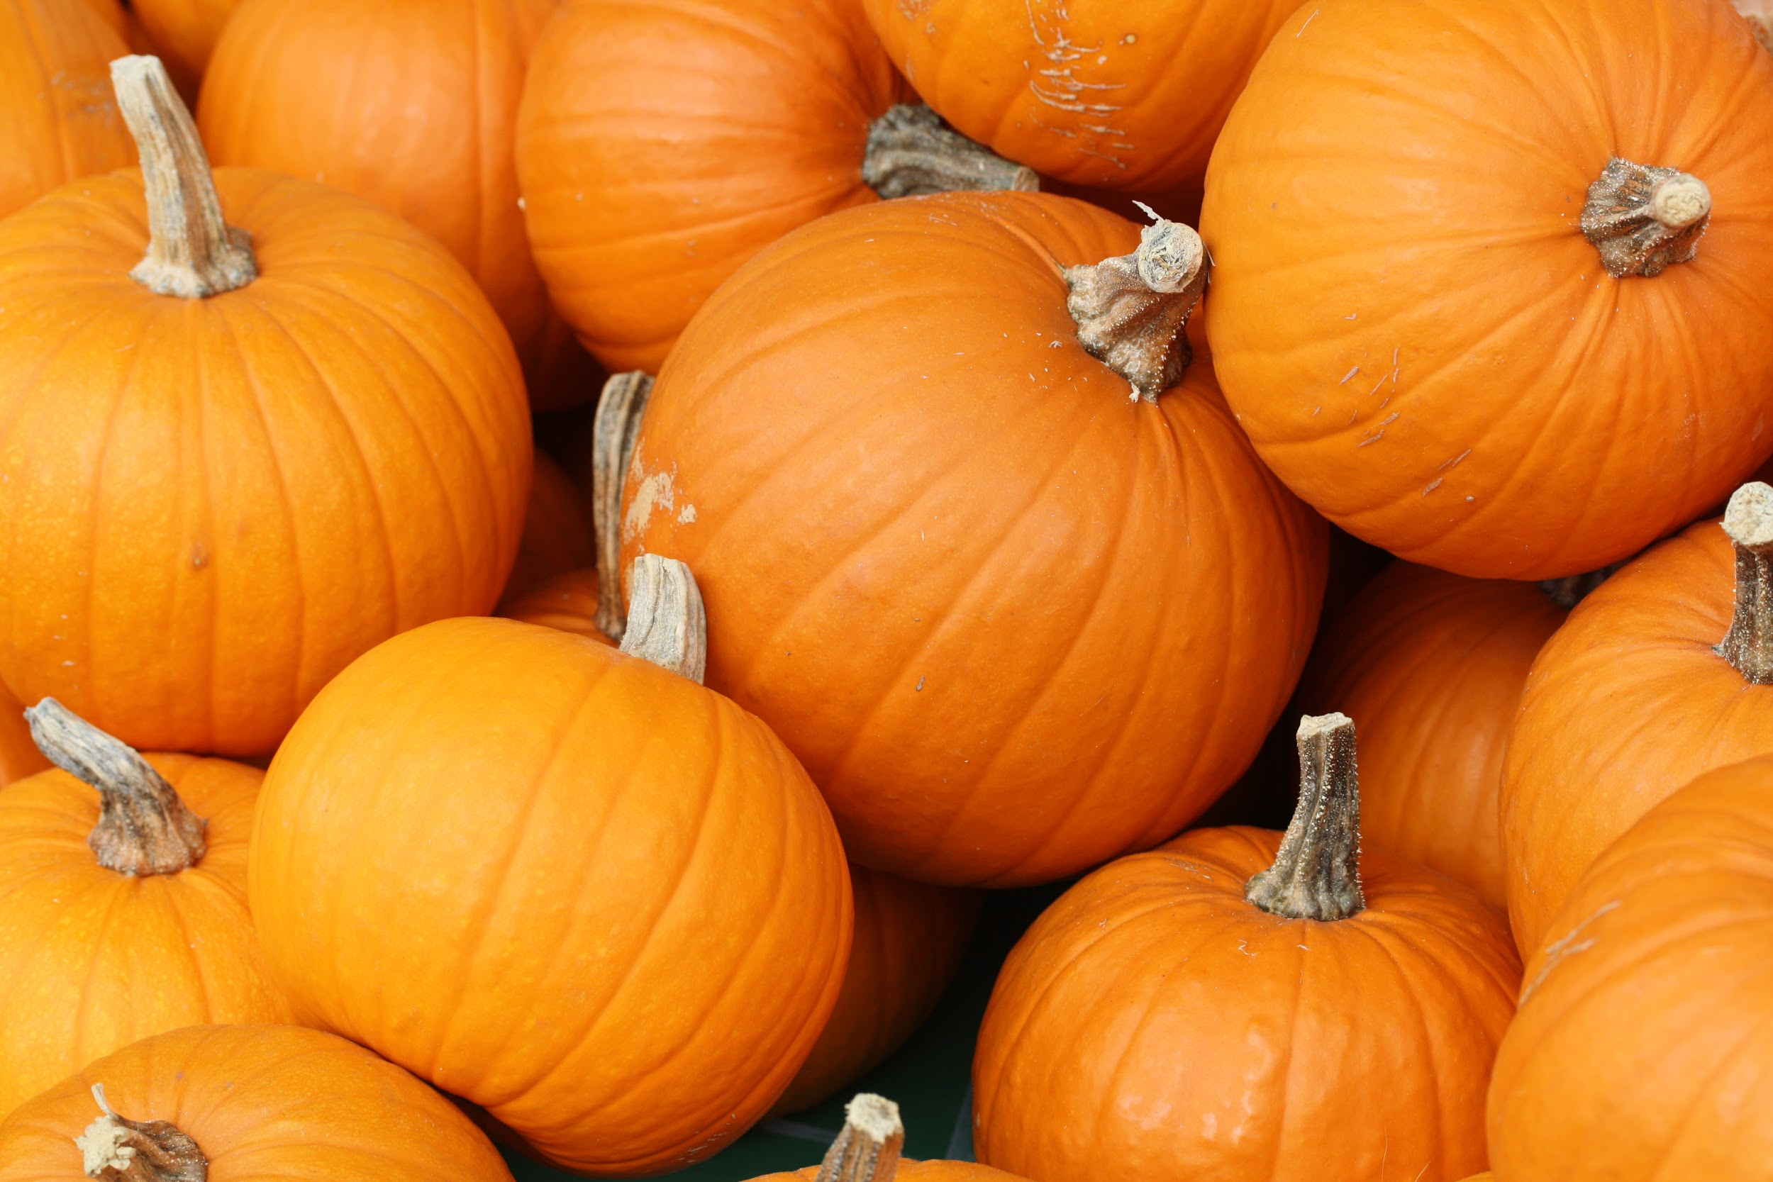
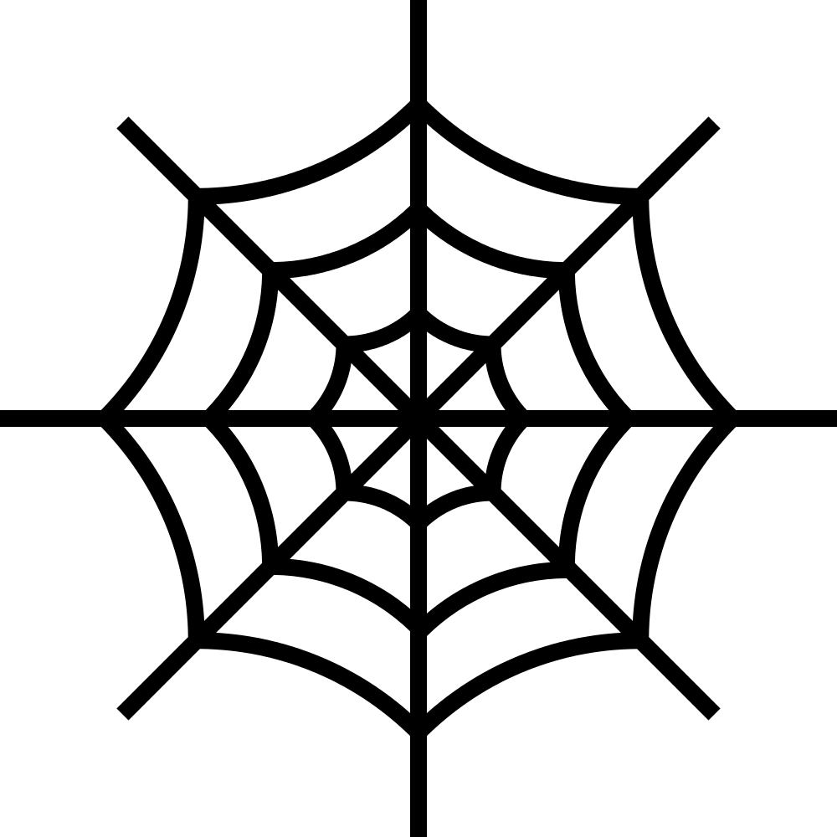
OCTOBER
Speech & Language
Monday | Tuesday | Wednesday | Thursday | Friday | Bonus
Talk about yesterday’s and today’s weather | Clean out the toy box and sort the toys.  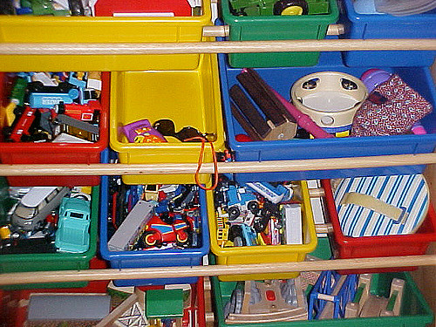 | Touch and name three body parts that come in pairs. | Wash dolls and toy cars in the bathtub. Talk about which are wet and which are dry. | Make different letter shapes with your body by bending and stretching. | Go outside and count all the things you can find that grow.
Walk around outside and make a big pile of leaves and a little pile of leaves. | Find soft things in the house. Talk about why they’re soft. | Yawn really big. Talk about feeling sleepy. | Find orange things in the house. | Lie on your back and move your legs like you’re riding a bicycle. Move fast then slow. | Name animals that live on a farm.  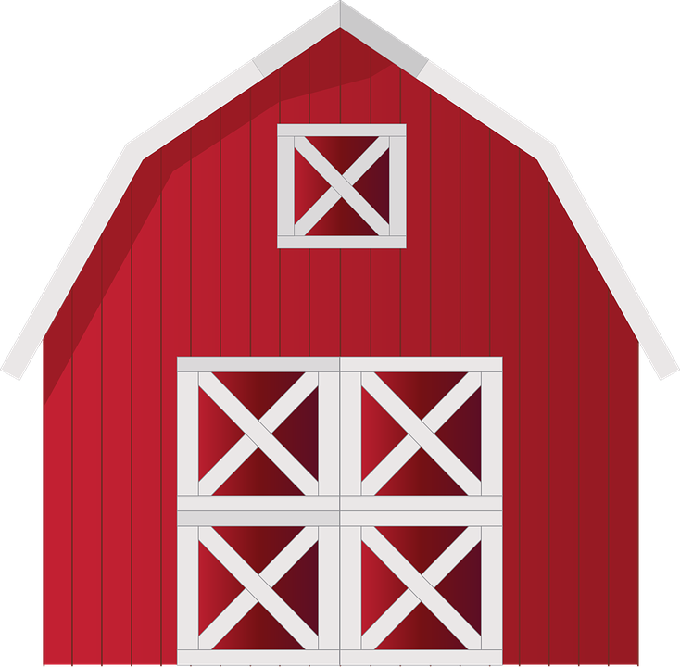
Talk about clothes people might wear in the fall (e.g., sweater, hat, jacket). | Look for things in the kitchen that are empty and things that are full. | Build tall and short towers with toy blocks. | Make a picture by gluing leaves onto a piece of paper.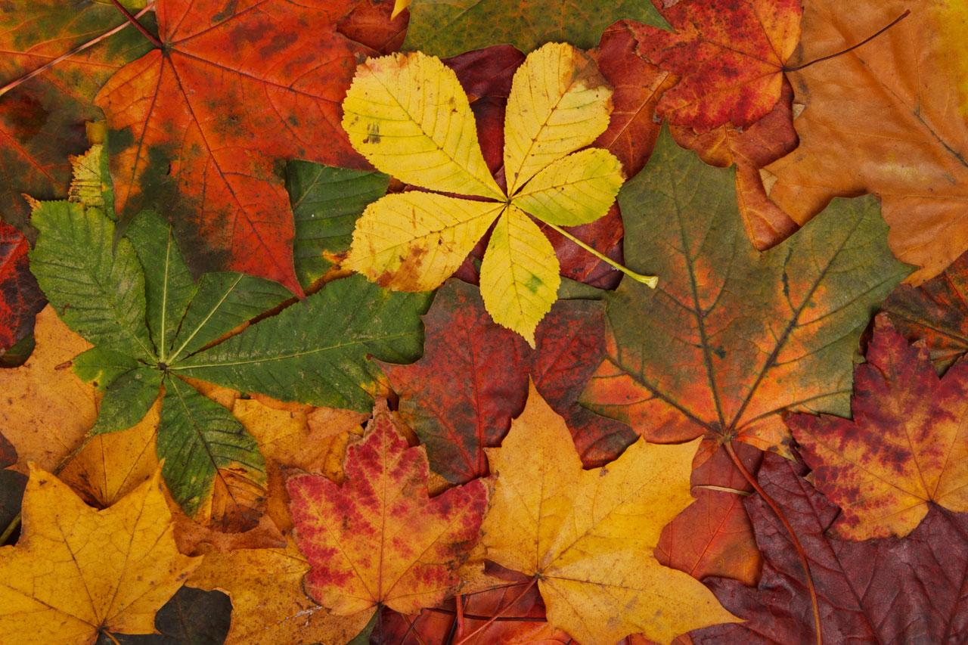 | Read a book about fall. Talk about what happens in the fall. | Make cookies shaped like triangles and circles.
Carve a pumpkin to make a jack-o-lantern. | Fill a squirt bottle with water and spray it on the sidewalk. Watch if the water dries fast or slow. | Stack books and talk about thick books and thin books. | Make a mask out of a paper bag. Draw a picture of the mask. | Decorate a shoebox to use as a house or a bed for a doll or stuffed animal. | Look for squirrels outside. Count how many you find.

Learning Target: With daily practice in the home, this resource can be used to enhance functional communication and generalization of skills.

