Directions: Try to do an activity together each day. Feel free to modify the tasks as needed (use pictures, offer choices, pointing…). For each picture, have your child describe the picture (What is it? What does it look like? Where do you find it? What is it made of?). Use this as a guide throughout the month to reinforce language skills. Have fun communicating!!
NOVEMBER
Speech & Language
Monday | Tuesday | Wednesday | Thursday | Friday | Bonus
Read a story about friendship. Talk about friends. | Talk about things that are cold. | Turn on the lights in the house, and then turn them off. Talk about on and off. | Line up cans by height from tallest to shortest. | Talk about animals that make good house pets. | Take turns hiding and finding a small object. Hide it in, on, and under bigger objects.
Talk about arms. Find arms on bodies and arms on furniture. | Talk about loud noises and quiet noises. | Count the toy cars and dolls in a toy box. Make a pattern (e.g., doll, car, doll, car). | Name clothes people wear to stay warm (e.g., sweater, coat, gloves, boots).  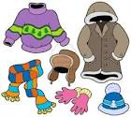 | Take a walk. Walk in front of, behind, and then beside each other. | Name things that can be opened (e.g., door, envelope, box of cereal).
Look at pictures in a favorite book and tell the story. | Find things that are scratchy and things that are furry. | Trace an outline of your hand. Talk about what fingers can do. | Put objects above, below, and through other objects. | Put groceries away. Talk about the items and where they go. | Put an object in a box. Shake the box and have your child guess what’s inside.
Talk about objects that go together (e.g., shoes/socks, salt/pepper, brush/comb). | Go outside and count all the trees you see.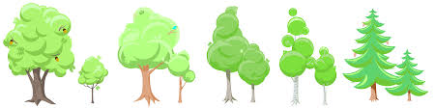 | Talk about animals that live in the forest and animals that live in the jungle. | Blow a piece of tissue across the table and talk about how it moves. | Perform a finger play or song about winter. | Look back at this month’s calendar. Talk about the important things that happened.
Learning Target: With daily practice in the home, this resource can be used to enhance functional communication and generalization of skills.

