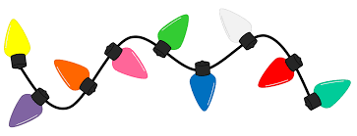
Directions: Try to do an activity together each day. Feel free to modify the tasks as needed (use pictures, offer choices, pointing…). For each picture, have your child describe the picture (What is it? What does it look like? Where do you find it? What is it made of?). Use this as a guide throughout the month to reinforce language skills. Have fun communicating!!
December
Speech & Language
Monday | Tuesday | Wednesday | Thursday | Friday | Bonus
Talk about the important dates in December (holidays, birthdays, etc.) | Cut a snowflake out of folded white paper. Attach a string and hang it from the ceiling or a window. Talk about snow. | Put pennies in a jar and rice in another jar. Shake the jars one at a time and compare their sounds. | Draw a face and talk about the different parts (e.g., ears, eyelashes, forehead, nose, chin, dimples). | Open both ends of a can. Talk through the can. Talk about how your voice sounds. | Go for an evening drive and look at stars or twinkling lights.
Make a card to give to a special friend or relative. | Talk about items that need to be stored in the freezer. | Read a book about a snow person. Then draw a snow person. | Sing a song about winter. Make up actions to go with the song. | Sort a pile of buttons by size or color.  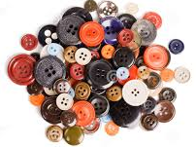 | Make and display special holiday decoration.
Look in the refrigerator and find foods that are white. | Watch a piece of ice melt. Talk about if it melts fast or slow. | Cut out footprint outlines and place them in a path around the house. Follow the footprints. | Talk about all the white things in a room. | Using paper strips and tape make paper chains. String the chains along a wall. | Draw pictures on a large sheet of paper and use the paper for wrapping a gift.
Bake cookies together. Talk about wet versus dry ingredients.  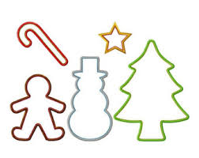 | Talk about different feelings (e.g., excited, tired, happy, sad, mad). | Talk about how things feel to the touch (e.g., soft, cold, fuzzy, hard). | Make a decoration using ribbons and bows. Talk about the different colors. | Pick up a room in the house. Talk about where the different items belong and why. | Go shopping to buy a present for a special person. Talk about what the person might like.
Learning Target: With daily practice in the home, this resource can be used to enhance functional communication and generalization of skills.

